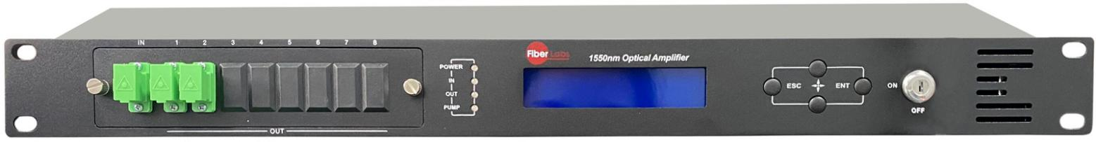
WE-1550-HD(HD) Erbium Doped Fiber Amplifier (EDFA)

1 Product Overview
1550nm optical fiber amplifier is the important optical relay transmission equipment in 1550nm optical fiber communication system. It mainly used for the long distance optical fiber transmission of TV image signal, digital television signal, telephone voice signal and data (or compressed data) signal. This product uses the high-performance erbium doped fiber and low noise pump laser, and built-in perfect embedded automatic monitoring system, to ensure the excellent performance indicators.

2 Block Diagram
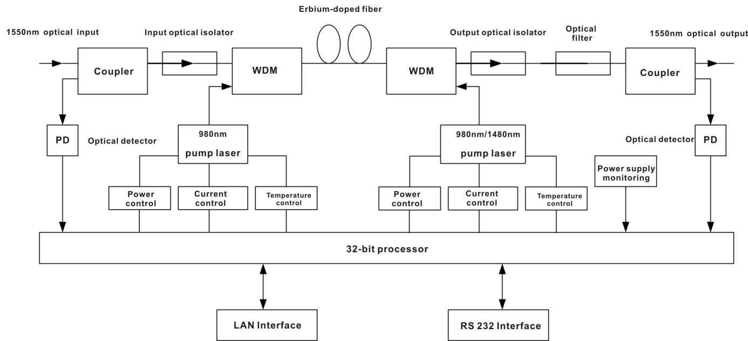
3 Technique Parameter
Item |  | Unit | Technique parameter | Remark
Operating bandwidth |  | nm | 1535 - 1565
Input optical power range |  | dBm | -10 - +10
Output optical power |  | dBm | 13-26
Output power stability |  | dBm | ±0.5
Noise figure |  | dB | ≤ 5.0 | Input optical power 0dBm
Return loss | Input | dB | ≥ 45
Return loss | Output | dB | ≥ 45
Pump leakage power | Input | dBm | ≤ -30
Pump leakage power | Output | dBm | ≤ -30
Optical connector type |  |  | FC，SC or LC
Power supply voltage |  | V | AC100 - 250V（50-60 Hz） DC48V
Consumption |  | W | < 30
Operating Temperature Range |  | ℃ | -5 - +55
Maximum operating relative humidity |  | % | Max 95% No Condensation
Storage Temperature Range |  | ℃ | -30 - +70
Maximum storage relative humidity |  | % | Max 95% No Condensation
Dimension |  | mm | 483(W)×340(D)× 44(H)

4 External Function Description
4.1 Front Panel Description
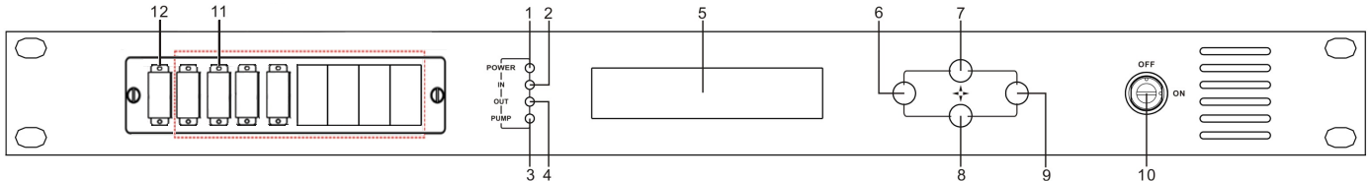

- Power indicator: One switching power supply is working – yellow; two switching power supplies are working – green.
- Optical input power indicator: This light turns on when the optical input power is > -10dBm.
- Pump working status indicator: Red light means the pump is not working; Flashing red light means the machine has broken down; Green light means the pump is working normal.
- Optical output power indicator: This light turns on when the optical output power is > +10dBm.
- 160×32 dot-matrix LCD screen
- Display the exit or cancel key of the setup menu.
- Display the up or increase key of the setup menu.
- Display the down or decrease key of the setup menu.
- Display the enter key of the setup menu.
- Pump laser switching key: “ON” means the pump laser is open and “OFF” means the pump laser is closed. Ensure the key is on “OFF” position before power on. After passing self-test, rotate the key to “ON” position according to the displayed message.
- Optical signal output: This interface is the optical signal output port of the device. The default connector type is SC/APC; the port number is 1-4 optional. Other specification requirements are specified by the customer.
There is invisible laser beam from this port after normal operating. So the port should not be aligned to the human body or the naked eyes to avoid accidental injury.
- Optical signal input.

4.2 Rear Panel Description
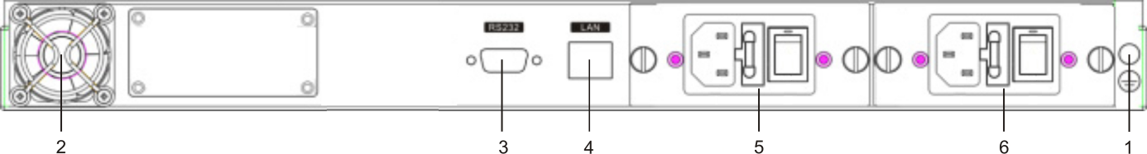
- Ground stud of the chassis | - Fan outlet | - RS232 interface
- RJ45 interface | - Power supply 1 | - Power supply 2

5 Menu System
5.1 Main Menu
Name | Display | Description
System Starting | xxxxxxx | Display vendor logo.
System Starting | xxxxxxx | Display model number.
System Starting | xxxxxxx | Start countdown / lock status.
Suspend Page | In: xx.x out: xx.x  Unit: dBm | Display the input / output optical power
Main Page | 1.Disp Parameters | Entry of parameter display menu
Main Page | 2.Set Parameters | Entry of parameter setting menu
Main Page | 3.Alarm Status | Entry of alarm information menu

5.2 Display Menu
Input Power: xx.x dBm | Input power, accurate to 0.1 dBm
Output Power: xx.x dBm | Output power，accurate to 0.1 dBm
Output ATT: x.x dBm | Output power ATT, accurate to 0.1 dBm
Pump1 Bias: x mA | Bias current of pump1, accurate to 1mA
Pump1 Temper: xx.x °C | Temperature of pump1, accurate to 0.1°C
Pump1 Tec: x.xx A | Cooling current of pump1, accurate to 0.01 A
Pump2 Bias: x mA | Bias current of pump2, accurate to 1m A
Pump2 Temper: xx.x °C | Temperature of pump2, accurate to 0.1°C
Pump2 Tec: x.xx A | Cooling current of pump2, accurate to 0.01 A
+5V Read: x.x V | +5V power supply voltage , accurate to 0.1 V
-5V Read: -x.x V | -5V power supply voltage , accurate to 0.1 V
System Temper: xx.x °C | Chassis temperature, accurate to 0.1°C
Serial NO.: xxxxxxxx | Device serial number
IP Addr: xxx.xxx.xxx.xxx | IP address
Mask: xxx.xxx.xxx.xxx | Subnet mask
Gateway: xxx.xxx.xxx.xxx | Gateway
Mac: xxxxxxxxxxxx | Physical address
Trap Addr1: xxx.xxx.xxx.xxx | trap1 address
Trap Addr2: xxx.xxx.xxx.xxx | trap2 address
Firmware Ver: Vx.xx | Firmware Version number

5.3 Setup Menu
Set Low Input Threshold | Set the input optical power low alarm threshold, range -10.0～9.9dBm
Set High Input Threshold | Set the input optical power high alarm threshold , range -10.0～10.0dBm
Set APC MODE | Set the constant optical power output function, on or off
Set Output ATT | Set the output optical power attenuation,range -4.0～0.5dBm
IP Addr | Set IP address
Mask | Set subnet mask
Gateway | Set gateway
Trap Addr1 | Set trap1
Trap Addr2 | Set trap2
Buzzer Switch | Set the switch of beeper
Restore Factory config | Restore the factory configuration，set content as shown above

5.4 Warning menu
Input Status: xxx | xxx= LOLOW:  Very low input optical power alarm
Input Status: xxx | xxx= LOW:  Low input optical power alarm
Input Status: xxx | xxx= HIGH:  High input optical power alarm
Input Status: xxx | Xxx= HIHIGH:  Very high input optical power alarm
Output Status: xxx | xxx= LOLOW:  Very low output optical power alarm
Output Status: xxx | xxx= LOW:  Low output optical power alarm
Output Status: xxx | xxx= HIGH:  High output optical power alarm
Output Status: xxx | Xxx= HIHIGH:  Very High output optical power alarm
Pump1 Bias: xxx | xxx= LOLOW:  Very low bias current of pump1 alarm
Pump1 Bias: xxx | xxx= LOW:  Low bias current of pump1 alarm
Pump1 Bias: xxx | xxx= HIGH:  High bias current of pump1 alarm
Pump1 Bias: xxx | Xxx= HIHIGH:  Very high bias current of pump1 alarm
Pump1 Temper: xxx | xxx= LOLOW:  Very low temperature of pump1 alarm
Pump1 Temper: xxx | xxx= LOW:  Low temperature of pump1 alarm
Pump1 Temper: xxx | xxx= HIGH:  High temperature of pump1 alarm
Pump1 Temper: xxx | Xxx= HIHIGH:  Very high temperature of pump1 alarm
Pump1 Tec: xxx | xxx= LOLOW:  Very low cooling current of pump1 alarm
Pump1 Tec: xxx | xxx= LOW:  Low cooling current of pump1 alarm
Pump1 Tec: xxx | xxx= HIGH:  High cooling current of pump1 alarm
Pump1 Tec: xxx | Xxx= HIHIGH:  Very high cooling current of pump1 alarm
Pump2 Bias: xxx | xxx= LOLOW:  Very low bias current of pump2 alarm
Pump2 Bias: xxx | xxx= LOW:  Low bias current of pump2 alarm
Pump2 Bias: xxx | xxx= HIGH:  High bias current of pump2 alarm
Pump2 Bias: xxx | Xxx= HIHIGH:  Very high bias current of pump2 alarm
Pump2 Temper: xxx | xxx= LOLOW:  Very low temperature of pump2 alarm
Pump2 Temper: xxx | xxx= LOW:  Low temperature of pump2 alarm
Pump2 Temper: xxx | xxx= HIGH:  High temperature of pump2 alarm
Pump2 Temper: xxx | Xxx= HIHIGH:  Very high temperature of pump2 alarm
Pump2 Tec: xxx | xxx= LOLOW:  Very low cooling current of pump2 alarm
Pump2 Tec: xxx | xxx= LOW:  Low cooling current of pump2 alarm
Pump2 Tec: xxx | xxx= HIGH:  High cooling current of pump2 alarm
Pump2 Tec: xxx | Xxx= HIHIGH:  Very high cooling current of pump2 alarm
+5V Status: xxx | xxx= LOLOW:  Very low +5V DC power supply alarm
+5V Status: xxx | xxx= LOW:  Low +5V DC power supply alarm
+5V Status: xxx | xxx= HIGH:  High +5V DC power supply alarm
+5V Status: xxx | Xxx= HIHIGH:  Very high +5V DC power supply alarm
-5V Status: xxx | xxx= LOLOW:  Very low -5V DC power supply alarm
-5V Status: xxx | xxx= LOW:  Low -5V DC power supply alarm
-5V Status: xxx | xxx= HIGH:  High -5V DC power supply alarm
-5V Status: xxx | Xxx= HIHIGH:  Very high -5V DC power supply alarm
Device Temper: xxx | xxx= LOLOW:  Very low chassis temperature alarm
Device Temper: xxx | xxx= LOW:  Low chassis temperature alarm
Device Temper: xxx | xxx= HIGH:  High chassis temperature alarm
Device Temper: xxx | xxx= HIHIGH:  Very high chassis temperature alarm

6.Communication Setup Descriptions
6.1 Communication Interface Description
- RS232 communication interface adopts DB9 standard connector, the pin definitions as follow:
The serial communication uses the standard NRZ form, 1 starts bit, 8 data bits, 1 stop bit and the baud rate is 38400.
1：No Connect | 2：TX | 3：RX
4：No Connect | 5：GND | 6：No Connect
7：No Connect | 8：No Connect | 9：No Connect
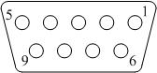
- LAN communication interface adopts RJ45 standard connector, the pin definitions as follow:
1：TX+ | 2：TX- | 3：RX+
4：No Connect | 5：No Connect | 6：RX-
7：No Connect | 8：No Connect
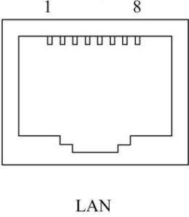

6.2 WEB Network Management
- Opening the IE browser and entering the equipment IP address leads to the following interface:
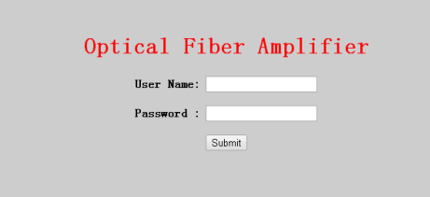
- Enter the user name admin and password 123456 (factory default), to show the following interface:
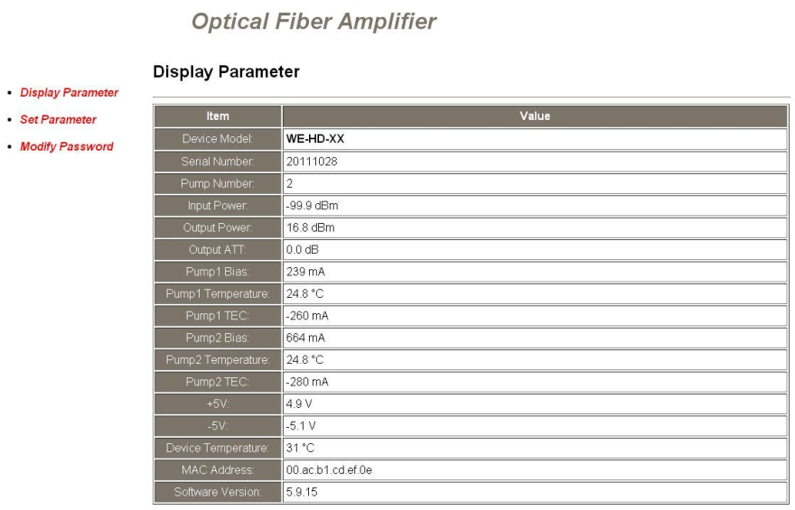
There are 3 sub-interfaces:
1. Display Parameter interface: Describes the equipment display menu.
2. Set Parameter interface: Change the equipment parameters in this interface.
3. Modify password interface: Change the login password in this interface.
- Click Set Parameter to open the following interface:
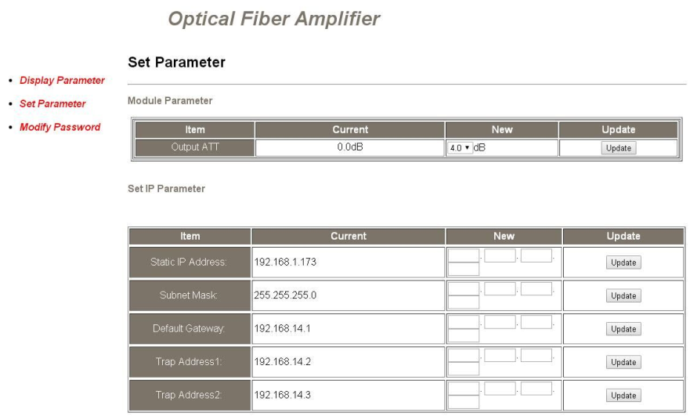
The Item shows the changeable parameters, Current—the current parameters; New—select or enter the new parameters; Update—update the parameters.
The update steps: Find the item which needs to be changed, select a new value, and click the Update button.

- Click Modify Password to open the following interface:
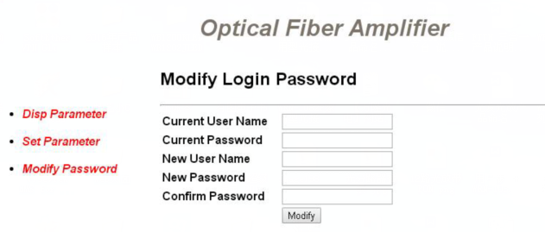

7 Attention
- Ensure the package is not defaced. If the equipment is damaged due to transportation or other reasons, please don't electrify to avoid worse damage.
- Before powering on, make sure that the grounding terminals of the chassis and power socket are reliably grounded, and the grounding resistance should be ＜4Ω, which can effectively protect against surges and static electricity.
- Optical amplifier is a highly technical professional equipment,its installation and debugging must be operated by professional technicians. Read this manual carefully before operating to avoid damage to equipment caused by fault operation or accident harm to the operator.
- When installing and debugging optical equipment, invisible laser beams may be emitted inside the fiber connector.Avoiding permanent harm to the body and eye, the fiber connector should not aim at the human body and human should not look directly at the fiber connector with the naked eye!
- There must be no shielding outside the ventilation holes of the device. Poor ventilation will cause the index to decrease, and in serious cases will cause damage to the device.
- When cleaning the fiber end face, you must confirm that the optical source is turned off.
- When the fiber connector is not in use, put a dust cover to avoid dust pollution and keep the end surface of the optical fiber clean.
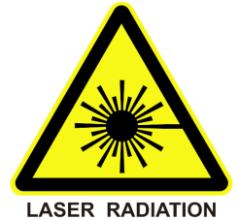
- When installing the fiber connector, apply appropriate force to avoid damage to the adapter. Otherwise, the output optical power may decrease.

