WF8630 Indoor User Amplifier

- SUMMARY
WF8630 is specialized for construction of the network.. High compact circuit and Aluminium-alloy, drawbench of surface. good index and fine outfit.

- PERFORMANCE CHARACTERISTICS
  - Adopt SOT-115 encapsulation RF module on access, reliable non-liner. Choose low-noise micro-wave push-pull circuit, small distortion and high S/N ratio.
  - Set up EQ and ATT on the right place, more convenient of debugging.
  - Aluminium housing small power consumption, high reliable, good performance and price ratio.

- PRINCIPLE DRAWING

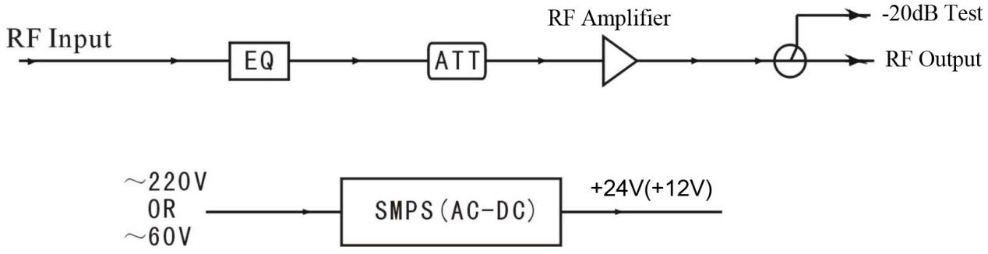

- CONSTRUCTION EXPLANATION

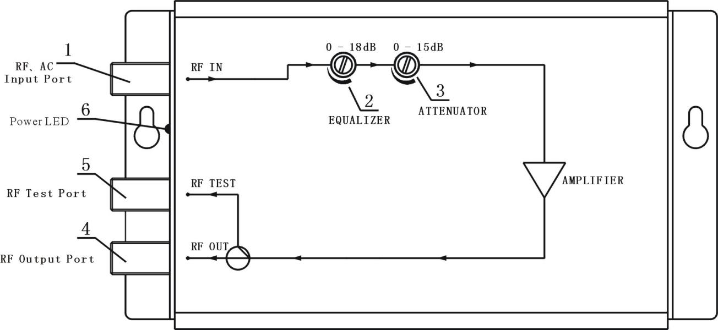

5. Performance Parameters
Item | Unit | Parameters
Forward Transmission
Frequency Range | MHz | 47 ~860
Rated Gain | dB | 30
Min Fill Gain | dB | ≥30
Rated Input Level | dBμV | 70±2
Rated Output Level | dBμV | 100
Flatness in Band | dB | ±1
Noise Figure | dB | ≤10
Return Loss | dB | ≥14
C/CTB (84 PAL-D) | dB | ≥58
C/CSO (84PAL-D) | dB | ≥56
Signal to Alternative Noise Ratio | dB | < 2
Gain Stability | dB | -1.0 ~ + 1.0
Backward Transmission
General Response
Special Impedance |  | 75
Power Voltage(50Hz) | V | A:AC (165～250)V; B:AC(35～60)V
Impulse Resisting Voltage | Kv | ＞5
Power consumption | VA | 8
Dimension | Mm | 178(L) x 100 (W) x55(H)

Hangzhou Prevail Communication Technology Co., Ltd
Hangzhou Prevail Optoelectronic Equipment Co., Ltd
Statement：Both are the registered trademarks of our company. We have the right to use either of them.

