WF8630L Bi-directional Indoor User Amplifier

- SUMMARY
WF8630L is specialized for construction of the network.. High compact circuit and Aluminium-alloy, drawbench of surface. good index and fine outfit.

- PERFORMANCE CHARACTERISTICS
  - Adopt SOT-115 encapsulation RF module on access, reliable non-liner. Choose low-noise micro-wave push-pull circuit, small distortion and high S/N ratio.
  - Set up EQ and ATT on the right place, more convenient of debugging.
  - Small power consumption, high reliable, good performance and price ratio.

- PRINCIPLE DRAWING
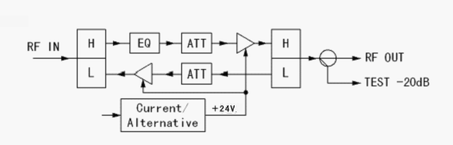

- CONSTRUCTION EXPLANATION

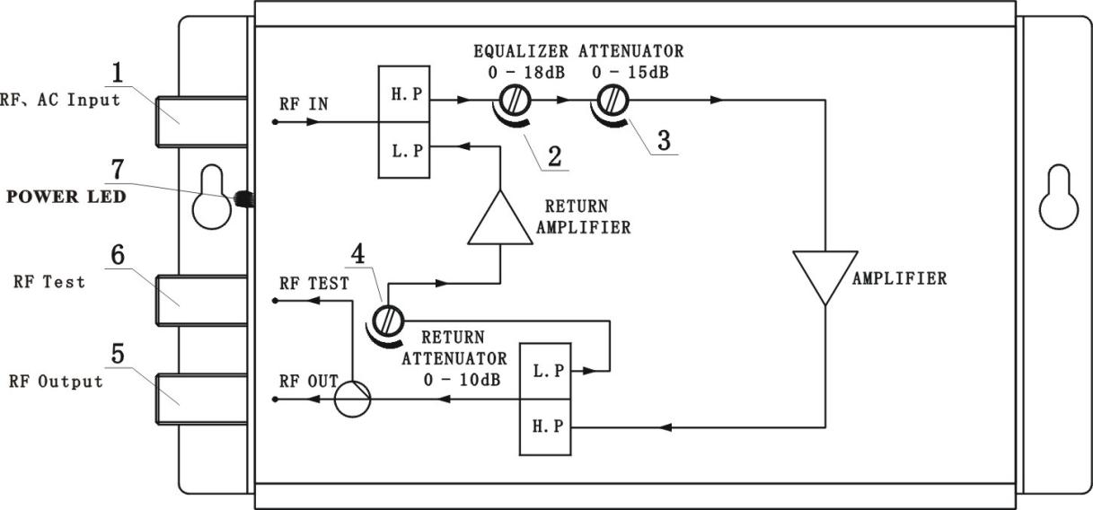

5. Performance Parameters
Item | Unit | parameters
Forward Transmission
Frequency Range | MHz |  | (47) 85~862
Rated Gain | dB |  | 30
Min Fill Gain | dB |  | ≥30
Rated Input Level | dBμV |  | 70±2
Rated Output Level | dBμV |  | 100
Flatness in Band | dB |  | ±1
Noise Figure | dB |  | ≤10
Return Loss | dB |  | ≥14
C/CTB (84 PAL-D) | dB |  | ≥58
C/CSO (84PAL-D) | dB |  | ≥56
Signal to Alternative Noise Ratio | dB |  | ≤2%
Gain Stability | dB |  | ≤± 1.0
Voltage Stroke | KV |  | 5
Backward Transmission
Frequency Range | MHz | 5~(30)65(or specified by user)
Rated Gain | dB | ≥15
Flatness In Band | dB | ±1
Noise Figure | dB | ≤12
Return Loss | dB | ≥16
MAX Output Level | dBμV | ≥110
Carrier to second  order inter modulation ratio | dB | ≥52
Carrier to Alternative noise ratio | 2% | ＜2
General Response
Power Voltage(50Hz) | V | A:AC (165～250)V ；B： AC(35～60)V
Power consumption | VA | 8
Impulse Resisting Voltage | Kv | ＞5
Dimension | Mm | 178(L) x 100 (W) x55(H)

Hangzhou Prevail Communication Technology Co., Ltd
Hangzhou Prevail Optoelectronic Equipment Co., Ltd
Statement：Both are the registered trademarks of our company. We have the right to use either of them.

